Week 2
1. Going deeper: batch normalization and residual connections
Why stacking more conv layers eventually hurts?
- Deeper networks can have higher training error.
- Their test error can also become higher.
The Degradation Problem refers to the phenomenon where the depth of a neural network increases, the accuracy of the model may not improve but instead worsen.
This occurs because optimization becomes more difficult as the network grows deeper, making it inefficient to train the model.
Why does degradation occur?
- Optimization difficulty
As the number of layers increases, optimizing the network becomes more difficult.
- The network has more parameters and a more complex optimization landscape.
- Gradient-based optimization may struggle to find a good solution.
- Training error can increase even when the deeper network has greater rc(representational capacity)
- Vanishing gradients

In backpropagation, gradients are propagated from the output layer to earlier layers.
- Gradients are multiplied by derivatives across multiple layers.
- If these derivatives are frequently smaller than 1, gradients can become small.
- Earlier layers receive weak learning signals and learn very slowly.
- Exploding gradients

The opposite problem can also occur.
- Gradients may become excessively large during backpropagation.
- Overfitting
- Information propagation difficulties
As information passes through many layers, useful features may become difficult to preserve and propagate.
How does ResNet solve the degradation problem?
Residual Networks (ResNet) introduce skip connections (shortcut connections) that allow information and gradients to bypass some layers.

Instead of learning a direct mapping:
H(x)
a residual block learns:
H(x)=F(x)+x
Where:
- x: input to the block.
- F(x): transformation learned by the stacked layers.
- F(x)+x: output after adding the shortcut.
Why does this help?
- Improves gradient propagation.
- Makes optimization easier.
- Allows layers to learn residual functions.
- Makes it easier to train very deep networks.
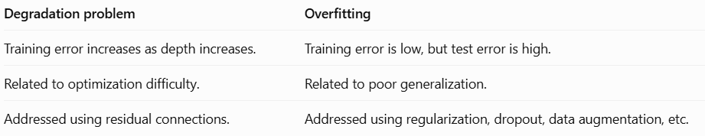
what batch norm computes
(BN) happens after each convolutional layer and before activation.
These plain networks are trained with BN, which ensures forward propagated signals to have non-zero variances.
They also report that backward-propagated gradients exhibit healthy norms.
This is important because it suggests that the degradation problem they observe is not simply the traditional vanishing/exploding gradient problem.
variance measures how much a model's predictions change when trained on different subsets of the
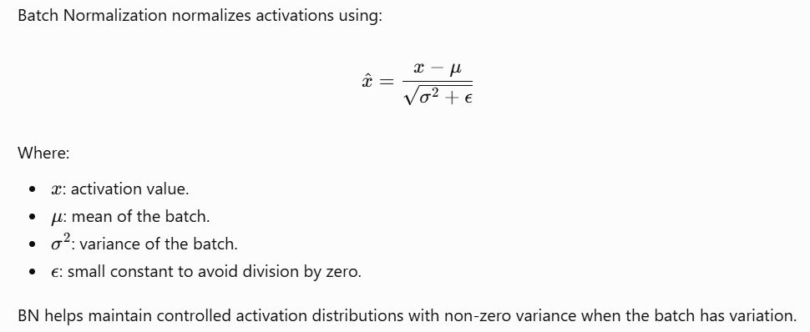
training data
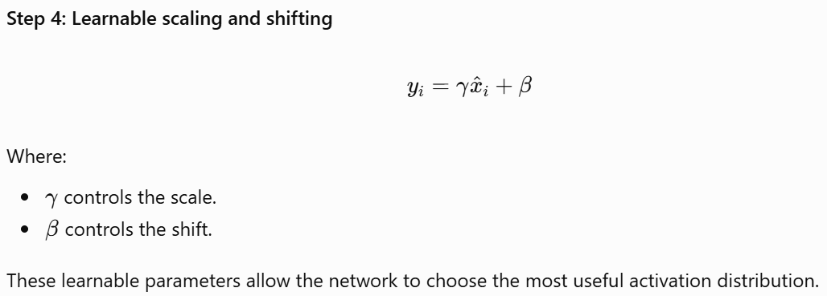
Why is this important?
If signals become nearly constant (variance approaches zero), neurons may receive very similar information, making learning less effective.
BN helps stabilize the signals flowing through the network, making optimization easier.
Important : BN cannot create variance from a batch whose values are all identical.
It stabilizes and normalizes existing variation; its learnable scale and shift parameters then transform the normalized values
why batch normalization stabilizes training?
it makes the distribution of activations more consistent during training,
which helps gradients behave more predictably and allows neural networks to train faster and more reliably.
There are four important reasons.
A. More predictable activation distributions
B. Better gradient behavior
C. Allows higher learning rates
D. Adds a regularization effect
What are identity mappings?
identity mapping means The output is exactly equal to the input.
In ResNet, the shortcut connection provides this identity path.
What if the input and output dimensions are different?
identity mapping itself is not responsible for matching 64 to 128 channels; a projection (usually a 1×1 convolution) is used.
Sometimes the dimensions of xx and F(x) don't match. For example:
- Input: 64 channels.
- Output: 128 channels.
You cannot directly add them.
ResNet can use a projection shortcut:
y=F(x)+Ws​x
Where Ws+x​ is usually a learned linear projection, often implemented using a 1x1 convolution.
This adjusts the dimensions so the two tensors can be added.
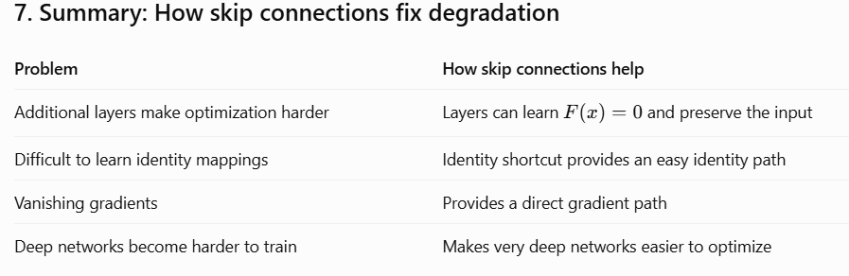
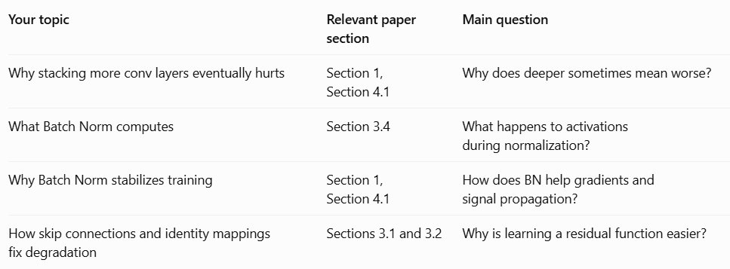
Read the BatchNorm2d documentation and note what it computes, and how training mode differs from evaluation mode
According to the official PyTorch documentation, BatchNorm2d normalizes the activations of a CNN across each channel. Its main purpose is to make training more stable and help the network learn efficiently.
- What does BatchNorm2d receive?
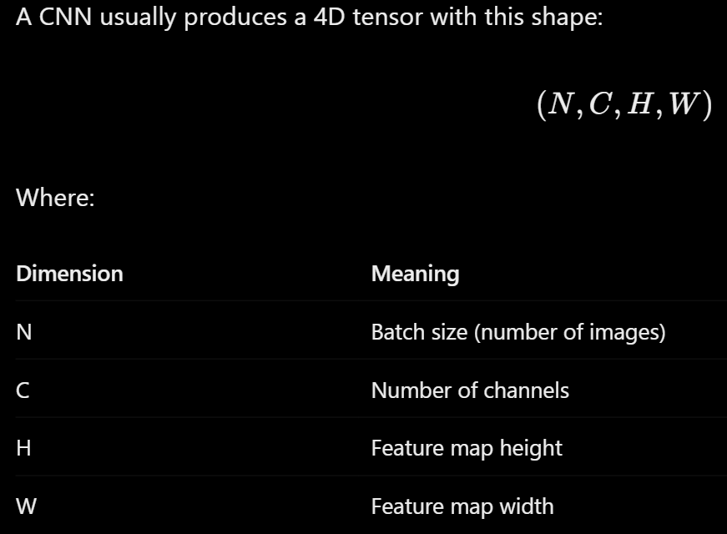
feature map is the output produced by a convolutional filter (kernel) when it processes an input image or another feature map in a CNN.
BatchNorm2d calculates separate statistics for each channel, not one statistic for the entire image or batch.
what batch normalization computes?
BatchNorm2d performs three main mathematical operations
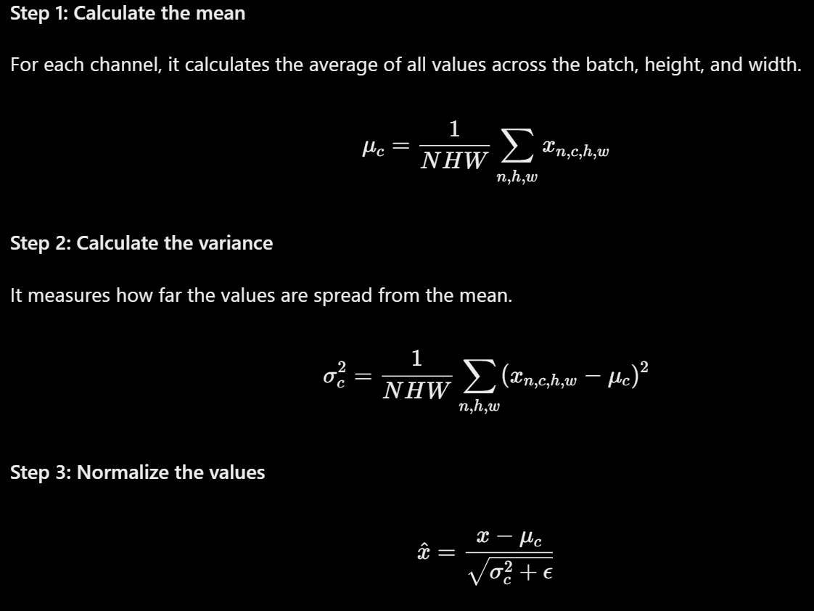
Why are Gamma and Beta used?
After normalization, BatchNorm applies two learnable parameters:
Gamma (γ): Controls the scale of normalized values.
Beta (β): Controls the shift of normalized values.
The final equation is: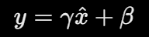
During training, the model learns these parameters using backpropagation Why?
Because forcing every activation to have exactly mean 0 and variance 1 might not always be optimal.
Gamma and Beta allow the network to adjust the normalized values to whatever distribution helps it learn
What are Running Statistics?
During training, every batch has its own mean and variance.
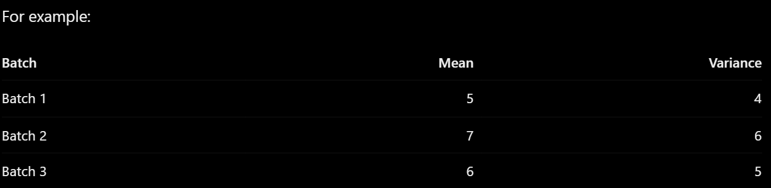
If we only use the current batch statistics, the normalization could behave differently depending on which batch is being processed.
To solve this, BatchNorm maintains:
running_mean running_var
These are moving estimates of the mean and variance across training batches.

How are they updated?
Where:
M=0.1 is the default momentum.
Example:
Suppose:
Old running mean = 4
Current batch mean = 6
Momentum = 0.1
Then:
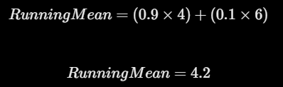
Note that PyTorch uses a biased variance estimator for normalizing the current training batch, but an unbiased variance estimator for updating running_var.
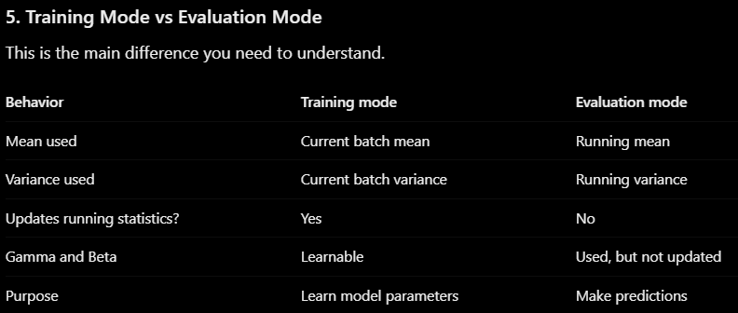
· BatchNorm2d normalizes each channel independently across N, H, and W.
· It calculates mean and variance for the current batch during training.
· It maintains running_mean and running_var for evaluation.
· Gamma and Beta are learnable parameters that scale and shift normalized values.
· model.train() uses batch statistics and updates running statistics.
· model.eval() uses running statistics without updating them.
2. Regularization and data augmentation
Dropout is a regularization technique that randomly turns off some neurons during training
Why do we need it?
Reduce overfitting by preventing neurons from becoming overly dependent on each other.
Weight Decay (L2 Regularization) is a regularization technique that penalizes large weights in a neural network.
Without regularization, some weights might become extremely large to fit the training data. Weight decay discourages this behavior.
Why do we need it? Prevent the model from relying on excessively large weights, helping reduce overfitting.
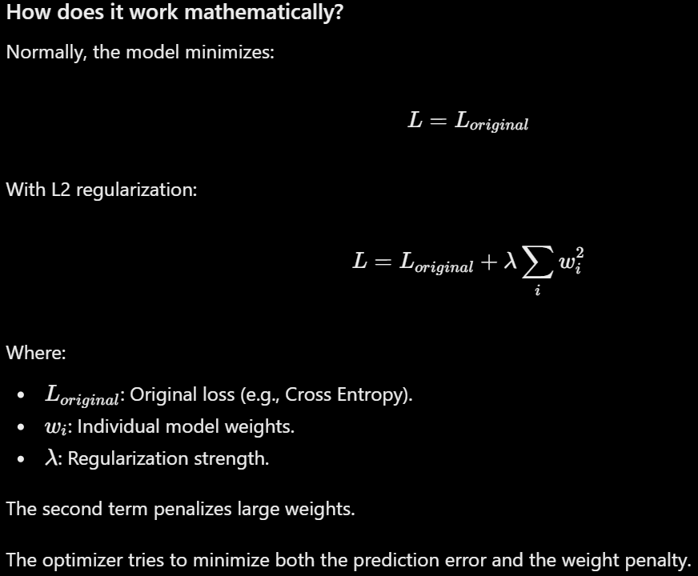
why data augmentation is a form of regularization?
Data augmentation means creating modified versions of your training images without changing their actual labels.
Why is it a form of regularization?
imagine your training dataset contains 1,000 cat images.
Without augmentation, the model sees only those 1,000 images repeatedly.
It might memorize specific characteristics:
The cat is always facing right. The cat is always centered. The images have similar lighting.
As a result, when it encounters a cat facing left or under different lighting, its performance might decrease.
With augmentation, the model sees different variations of the same images.
It learns that:
A cat is still a cat when flipped. A cat is still a cat when slightly rotated. A cat is still a cat under different lighting.
Therefore, the model learns more general features instead of memorizing the exact training images.
Main purpose: Improve generalization by increasing the diversity of training examples and making memorization harder.
3.Transfer learning and fine tuning?
What is Transfer Learning?
Imagine you want to build a CNN that classifies images of different animals.
You could train a CNN from scratch, but it would need to learn everything:
Edges and lines. Shapes and textures. Eyes, ears, and other patterns. Complex object representations.
This requires a lot of data and computational resources.
Instead, you can use a CNN that has already been trained on a large dataset such as ImageNet.
For example, ResNet18 has already learned useful image features from millions of images.
Feature extraction versus fine tuning
Feature extraction means Use the pretrained CNN to extract image features, but don't change its learned weights.
For example, ResNet18 has two main parts:
1.Feature extractor: Learns visual patterns.
2.Classifier: Makes the final prediction.
Suppose ResNet18 was originally trained to classify 1,000 ImageNet classes.
You want to classify 10 animal classes.
You keep the feature extractor and replace the original classifier with a new classifier for your 10 classes.
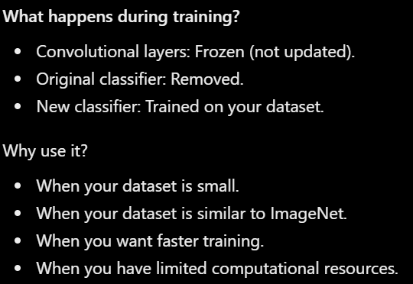
Fine-Tuning
Means Take a pretrained CNN and allow some or all of its pretrained layers to learn from your new dataset.
For example:
You use ResNet18 pretrained on ImageNet to classify medical images.
The pretrained model already understands general visual features, but medical images may have different characteristics.
You replace the classifier and unfreeze some of the deeper convolutional layers.
The model can now adapt its learned features to your new dataset.
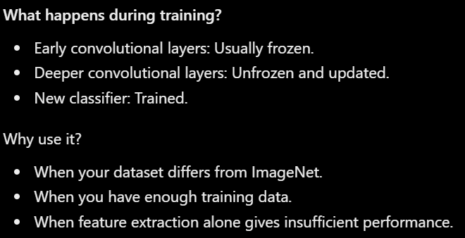
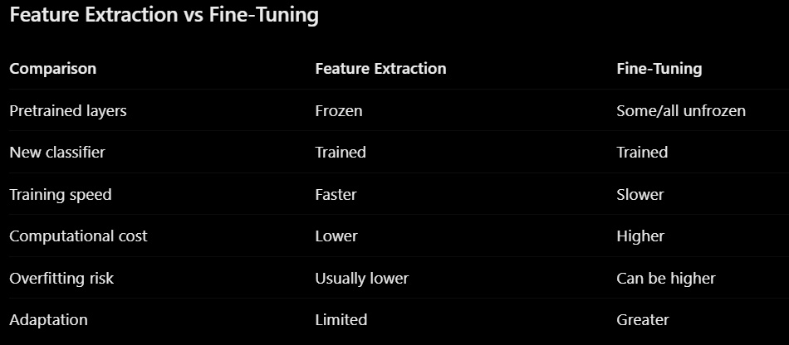
Freezing layers means preventing its weights from being updated during training.
Why do we freeze layers? A pretrained model already learned useful information.
You don't necessarily want to destroy this knowledge by updating every layer using a small dataset. Freezing protects the pretrained weights.
Important: Freezing and unfreezing are controlled using requires_grad.
discriminating learning rates
learning rate controls how much the model changes its weights during each optimization step.
A learning rate of 0.001 determines the size of the optimizer's parameter updates.
High learning rate: Larger updates.
Low learning rate: Smaller updates.
discriminating learning rates mean
Use different learning rates for different layers of the same neural network.
Why? Because pretrained layers already contain valuable knowledge.
You don't want to change their weights too aggressively.
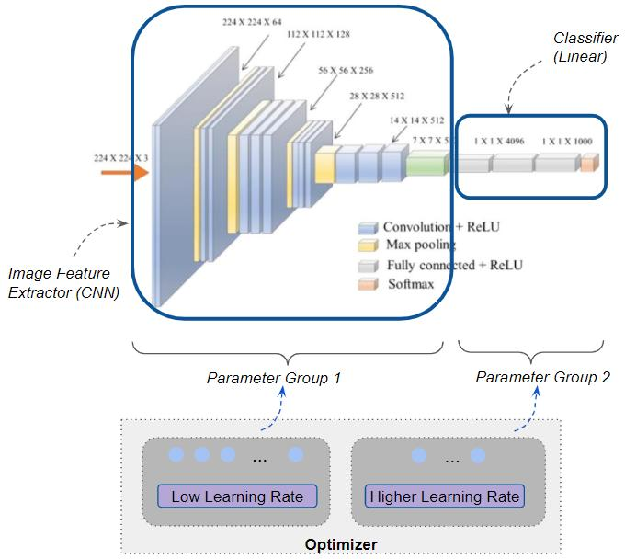
The idea:
Earlier layers: Very small updates.
Deeper pretrained layers: Slightly larger updates.
New classifier: Larger updates.
This helps preserve pretrained knowledge while allowing the new classifier to learn effectively
matching ImageNet mean and standard deviation.
This is an important concept when working with Transfer Learning and Pretrained CNNs, especially when using models such as ResNet, VGG, and EfficientNet.


